**You work for XYZ Corporation. Your corporation is working on an application and they require secured web servers on Linux to launch the application.**

**Step-1) created EC2 instance in** US-East-1**using amazon Linux, with apache server with text “HELO WORLD”**

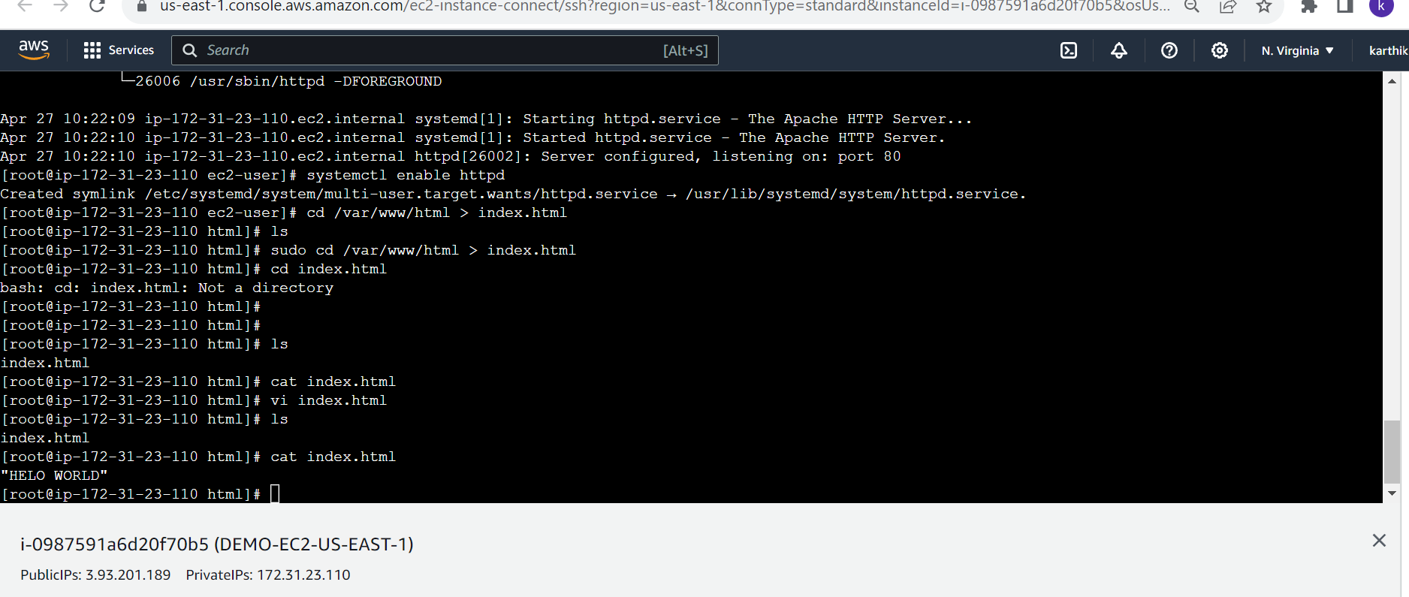

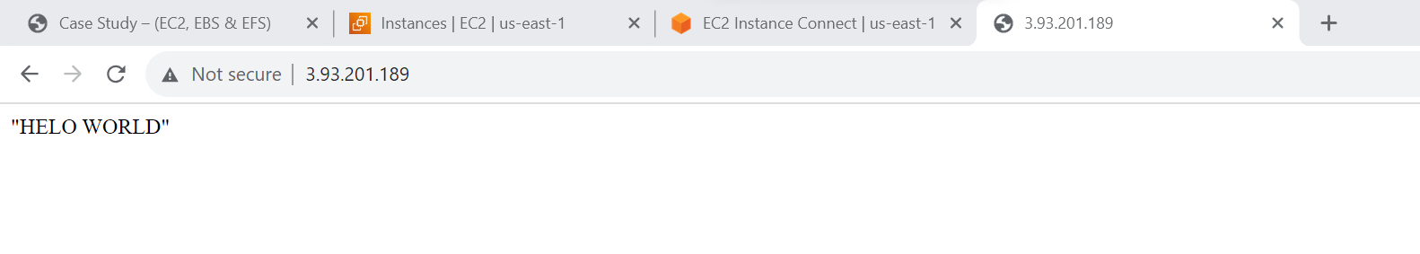

**Srtep-2) created AMI image using EC2-insance AMI**

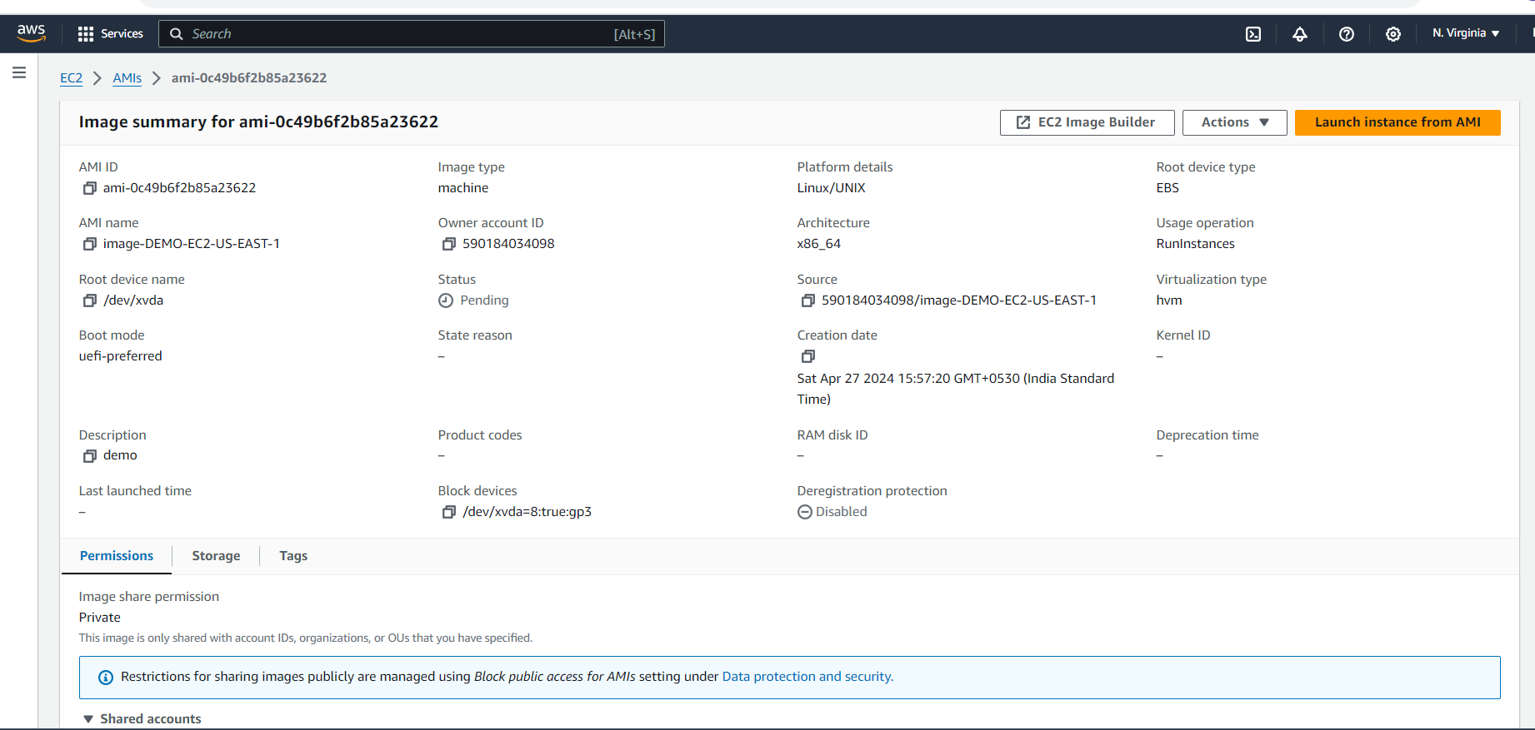

**Step-3) copied AMI image to** US-West-2 (Oregon)

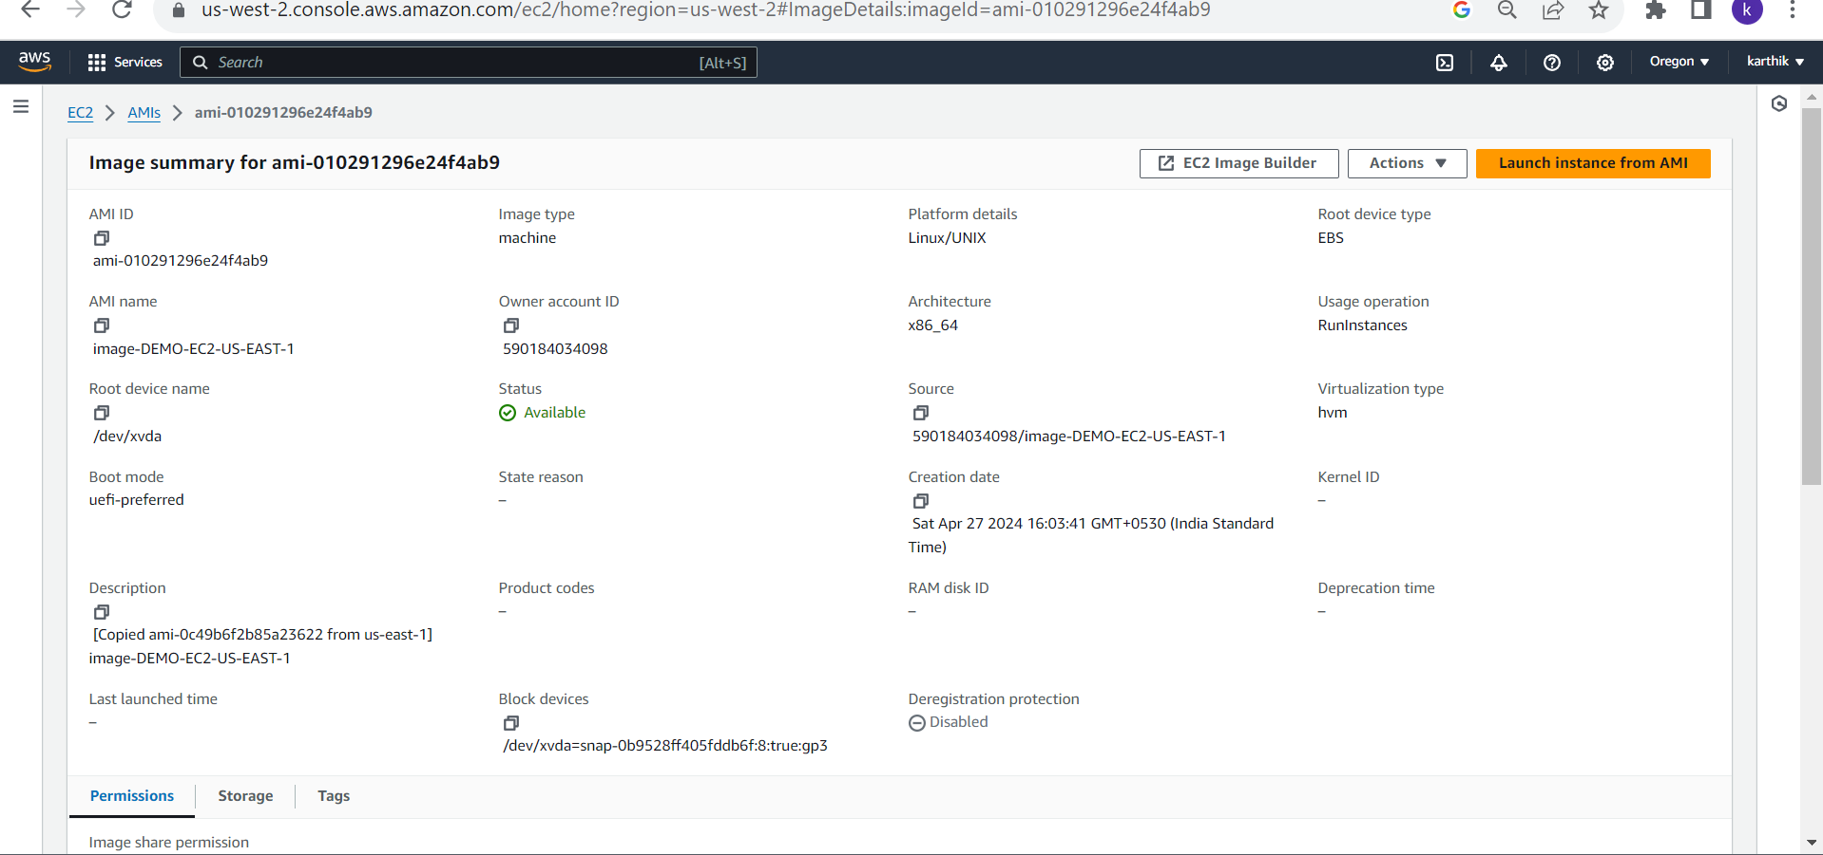

**Step-4) created EC2-instance in** US-West-2 using AMI image copied from US-East-1.

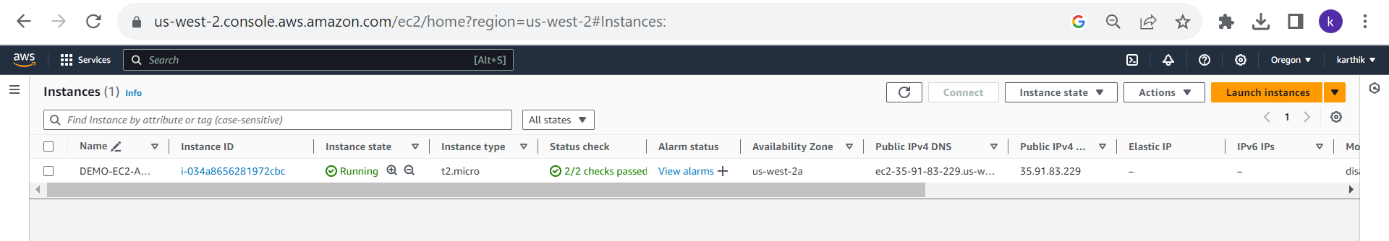

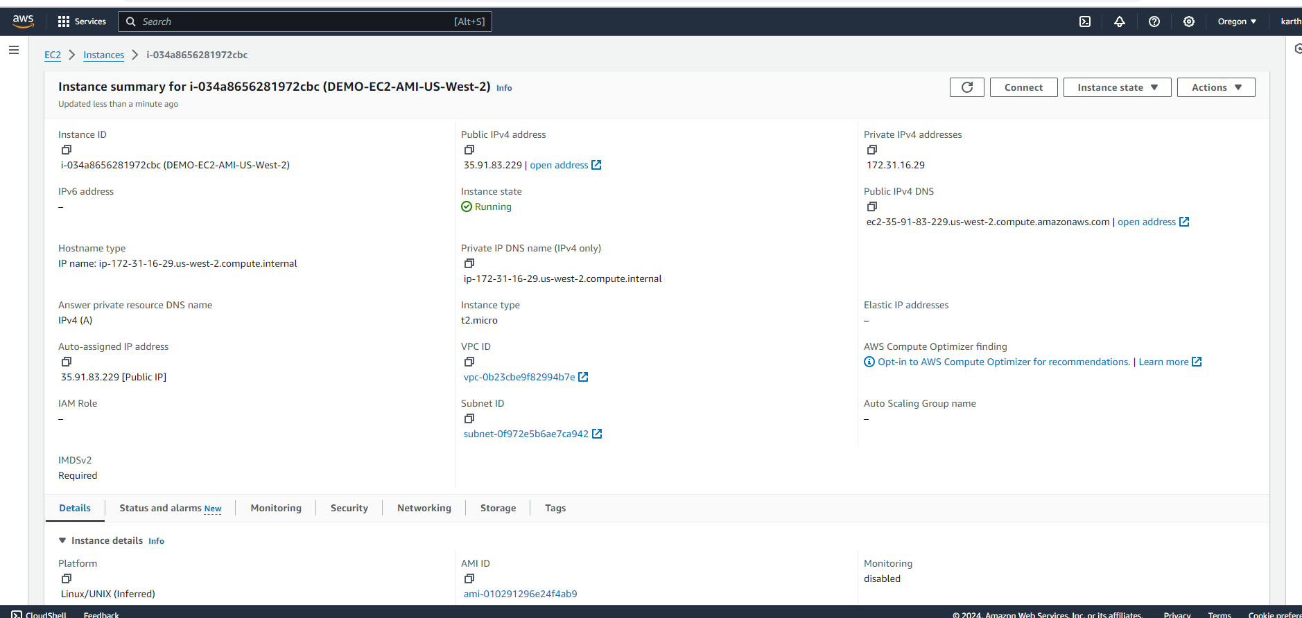

**Step-5) checked the webserver exit or not was created in using** US-East-1 **in** US-West-2.

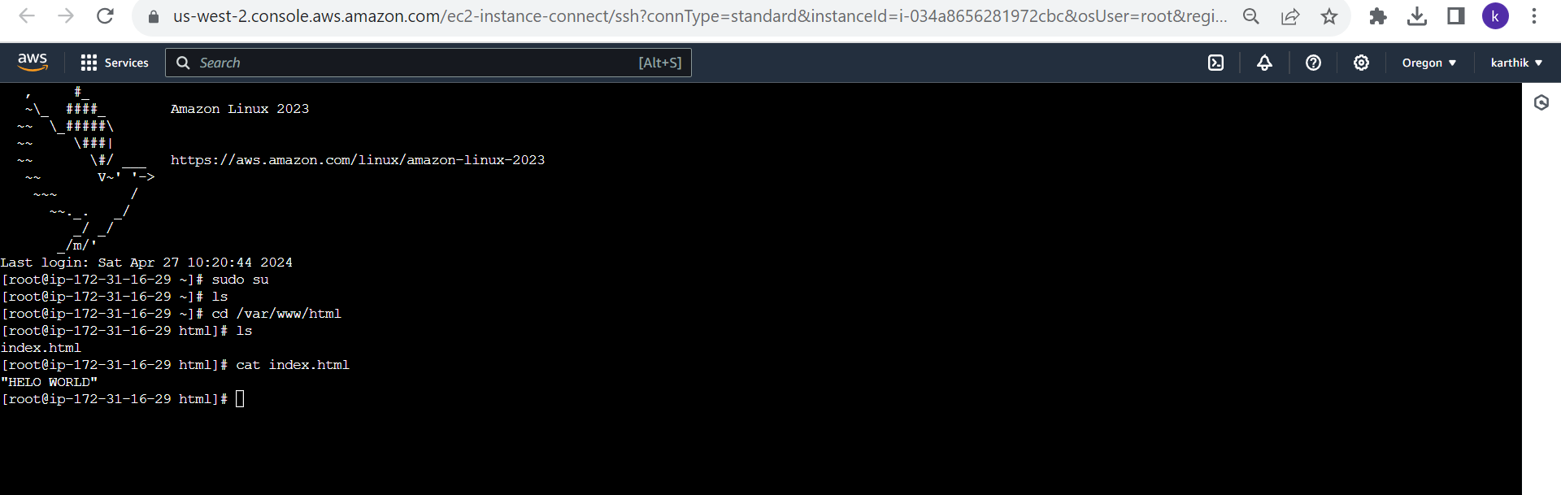

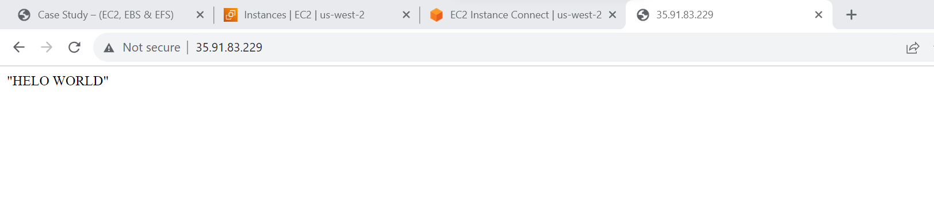

**Step-6) created new 2 volumes, 12gb and 15gb**

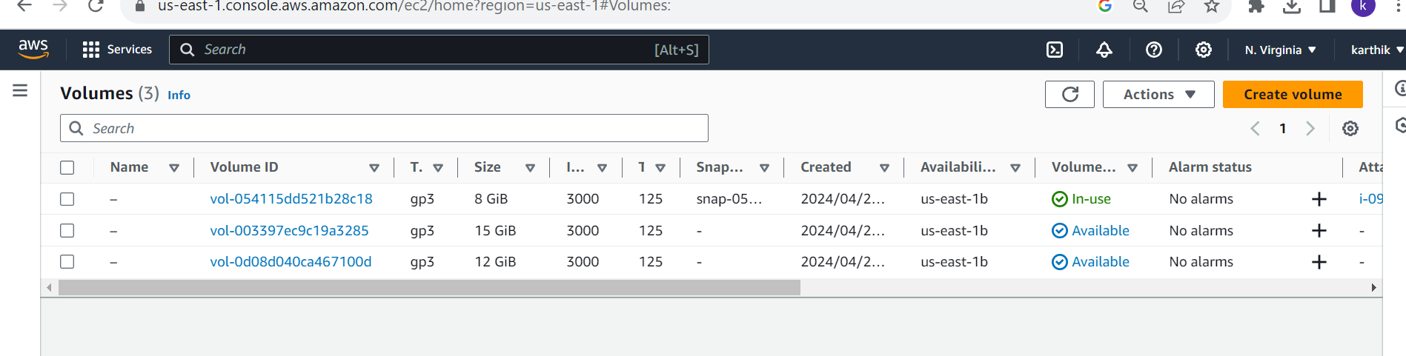

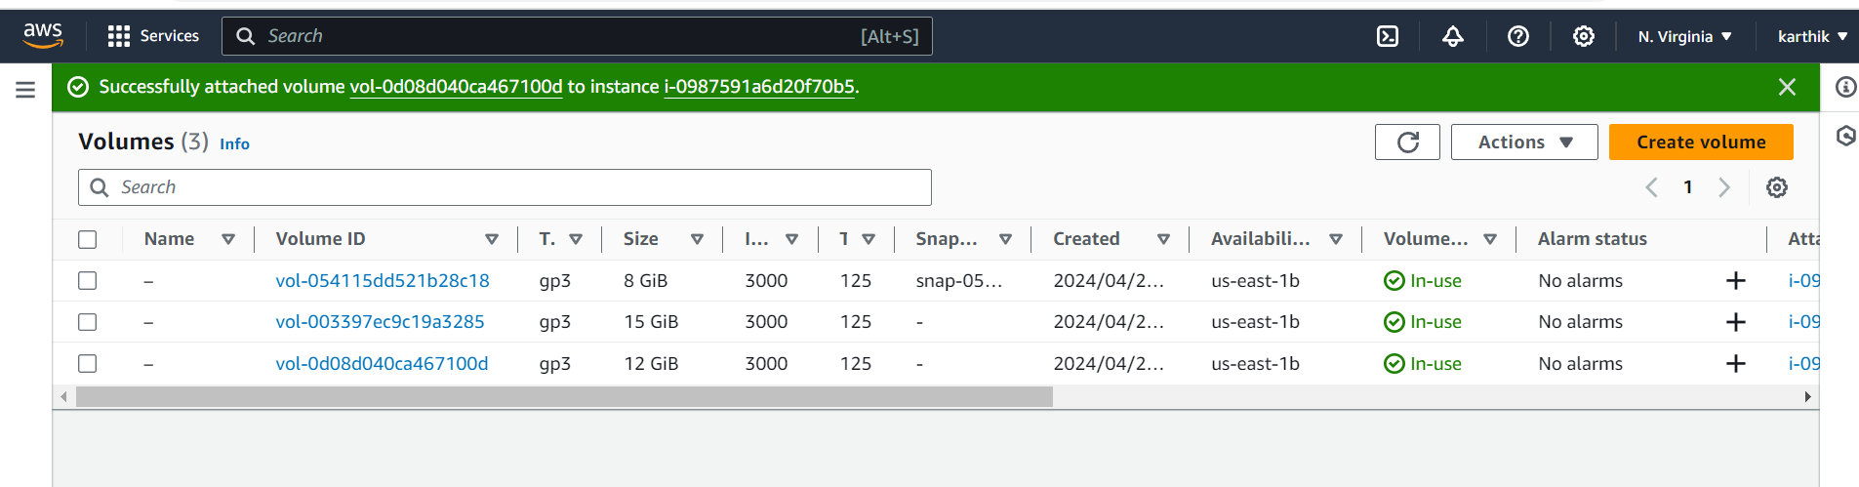

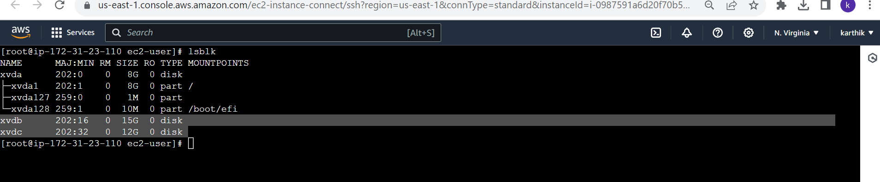

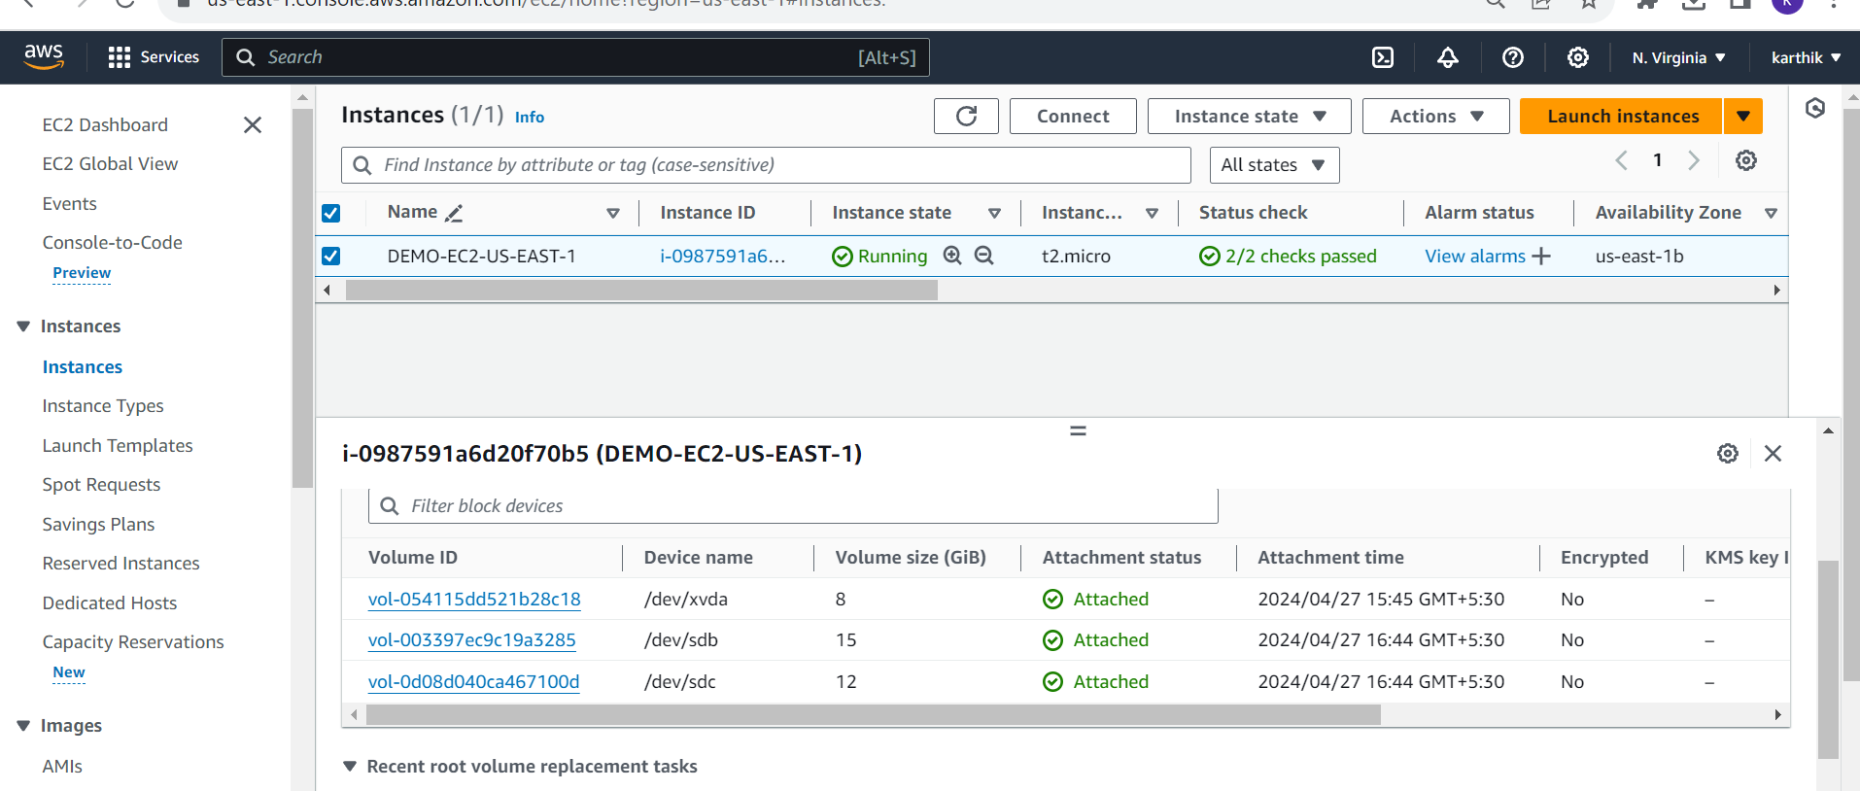

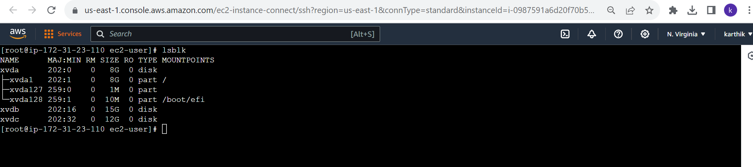

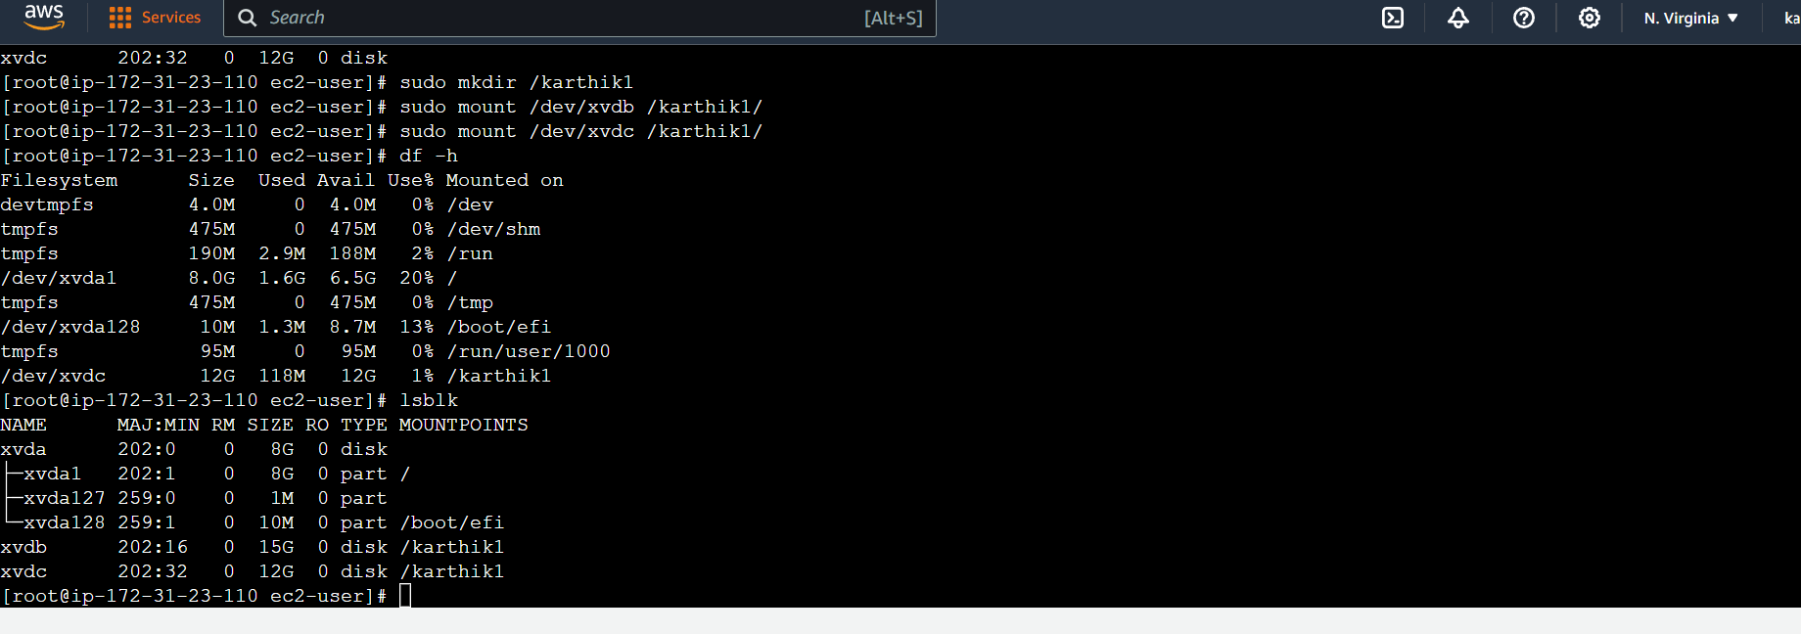

**Step-7) detached & deleted 15 gb volume**

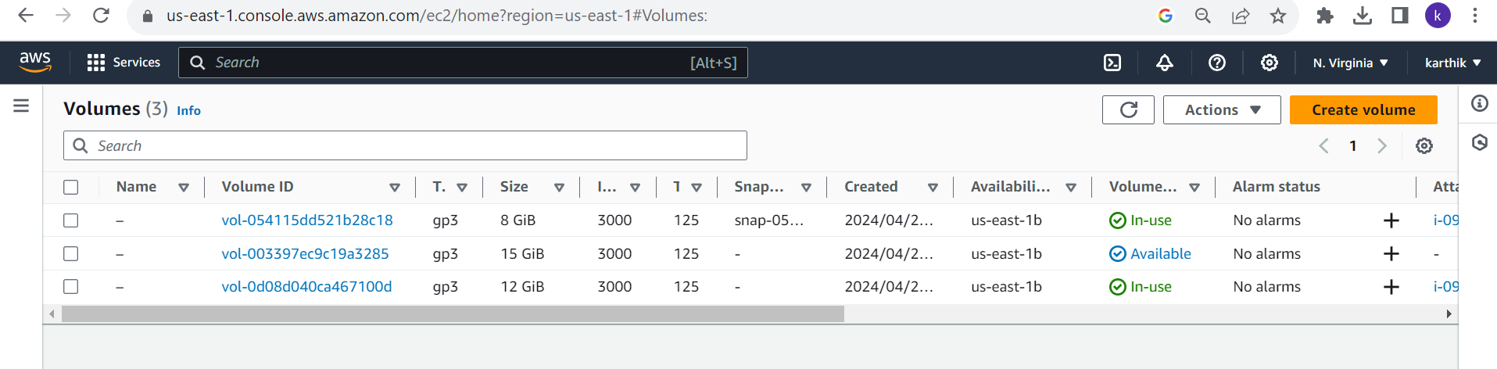

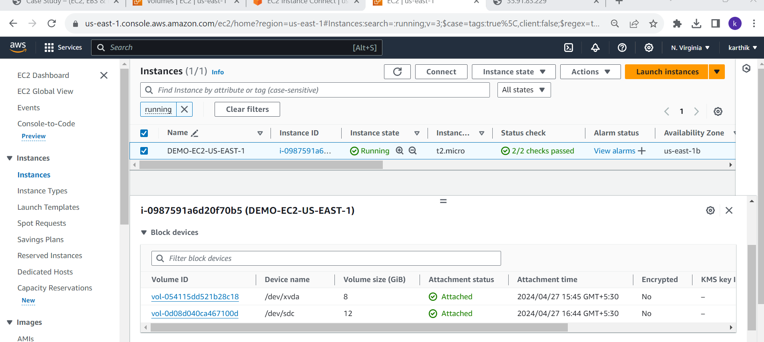

**Step-7) extended the volume from size 12gb form 20gb**

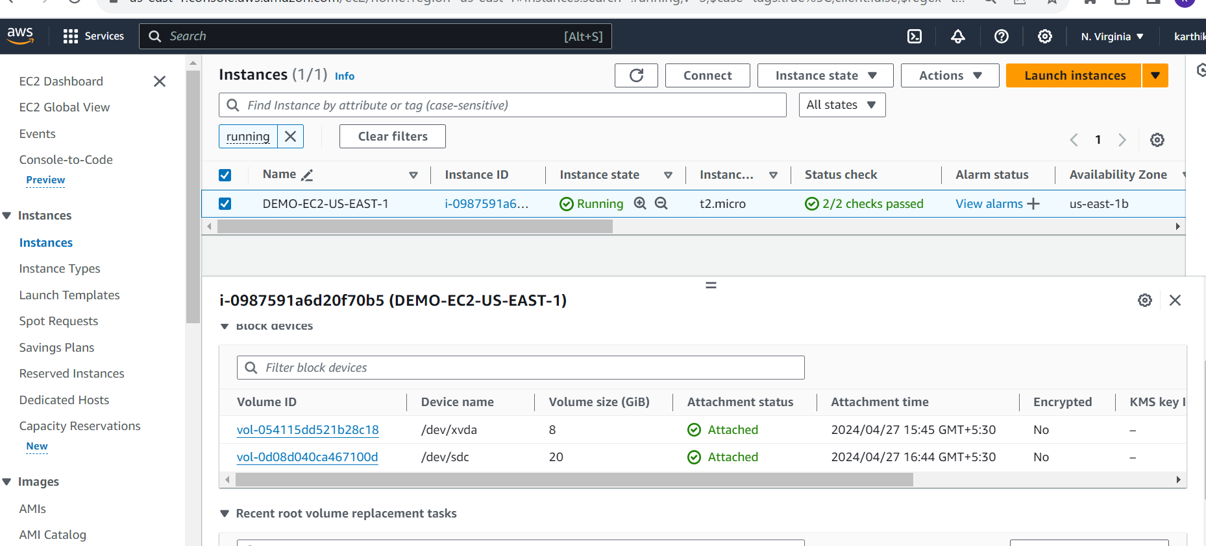

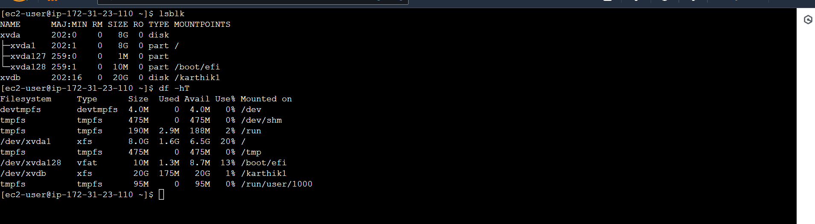

**Step-8) EBS backup taken**

